**RESUME**

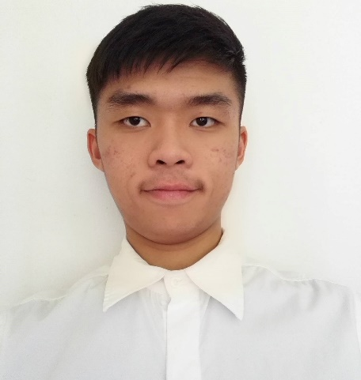

**Name :** HOH MUN KEONG

**Address :** No,22,Taman Sungai Klau, 27630 Raub,  
 Pahang.

**Phone :** 017-9755433

**Email :** [kven888@gmail.com](mailto:kven888@gmail.com)  
**Age :** 23  
**Gender :** Male  
**Nationality:** Malaysian

**INTERNSHIP AVAILABILITY**

|  |
| --- |
| Date : 24th June 2017 to 1th September of total 10weeks. |

**EDUCATION BACKGROUND**

|  |  |  |
| --- | --- | --- |
| **2014 - Expected to 2018** | **University Malaysia Sabah**  *Bachelor of Engineering with Honors (Computer Engineering)* | **CGPA 3.45** |
| **2012 - 2013** | **SMK Mahmud,Raub ,Pahang**  *Sijil Tinggi Persekolahan Malaysia (STPM)* | **CGPA 2.67** |
| **2007 - 2011** | **SMK Sungai Ruan Raub ,Pahang**  *Sijil Pelajaran Malaysia(SPM)* | **5A, 2B+, 3C** |
| **2001 - 2006** | **SJK (C) Sungai Klau**  *Ujian Pencapaian Sekolah Rendah(UPSR)* | **2A, 5B** |

**WORKING EXPERIENCE**

|  |  |
| --- | --- |
| **December 2011 – March 2012** | **Casino De Genting, Genting Highland, Pahang**  Croupier |
| **16 August 2014 -17 August 2014** | **Sekolah Jenis Kebangsaan (Cina) Sungai Klau, Raub ,Pahang**  Volunteer of Bazaar event |

**CO-CURRICULAR ACTIVITIES**

|  |  |
| --- | --- |
| **29 November 2016** | Participant of industrial visit to Petropipe Sdn. Bhd., Sabah |
| **2013** | Participant of leadership camp in SMK MAHMUD |
| **2013** | Participant of First Aid Course in SMK MAHMUD |
| **2012 - 2013** | Librarian of SMK MAHMUD |
| **2012 - 2013** | Member of Police Cadet SMK MAHMUD |
| **2007 - 2010** | Member of Science Club SMK SUNGAI RUAN |
| **2009** | Participant of study tours organized by Science Club SMK SUNGAI RUAN |
| **2007 - 2010** | Member of Firefighter Cadet SMK SUNGAI RUAN |

**Achievements**

|  |  |
| --- | --- |
| **2015** | Dean’s List for Semester 2 2014/2015 |
| **2013** | Participant of leadership camp in SMK MAHMUD |
| **2010** | Third runner for Basketball competition during One Student One Sport Event |

**SKILLS**

|  |  |
| --- | --- |
| **Software** | -Microsoft Office included (Word, Excel and Power Point)  -Visual Studio  -MATLAB  -Dev C++  -Altera Quartus II  -Model Sim  -Multimedia Logic  -Eagle  -Proteus |
| **Programming Language** | -Basic C and C++ |
| **Equipment** | -Oscilloscope  -Arduino  -FPGA on DE2-115 board |
| **Project** | -Construct a Vending Machine using Arduino |

|  |  |
| --- | --- |
| **Malay** | Satisfy in speaking, reading, writing, and listening |
| **English** | Satisfy in speaking, reading, writing, and listening |
| **Mandarin** | Satisfy in speaking, reading, writing, and listening |

**LANGUAGE ABILITIES**

**PERSONAL QUALITIES**

* Independent
* Well-organized
* Enjoys learning
* Positive attitude
* Gets along well with others
* Patient

**REFERENCE**

|  |  |
| --- | --- |
| **DR. RENEE CHIN KA YIN**  Head of Electronic (Computer) Engineering Program  Faculty of Engineering  Universiti Malaysia Sabah  Email: reneekychin@ums.edu.my  Tel: +6-088-320000 x 3193 | **DR. MAZLINA BINTI MAMAT**  Industrial Training Coordinator  Electronic (Computer) Engineering Program  Faculty of Engineering  Universiti Malaysia Sabah  Email: mazlina@ums.edu.my  Tel: +6-088-320000 x 3090 |